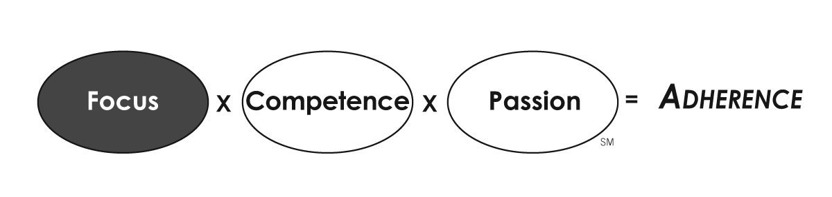
Meeting Rhythm
Meeting | Frequency | Duration | Attendees | Date/Time | Objective
Huddle | Daily | 10 mins. | Direct reports | 7:30 am | Quick synch up. ID your One Thing for today.
Team Update | Weekly | 45 mins. | Direct reports | Monday at 1:30 pm | Short-term initiatives update. Focus on those that are off track and identify actions to get them back on track.
Department Dialog | Monthly | 1 hour | Whole department | Last Friday at 11:30 am | Brief look back at departmental performance and reinforce the department’s focus for next month. Recognize outstanding performance. Engage attendees with questions or solicit input on a challenge or problem you need help solving. Use this time to get real work done, not to just share information.
Strategy Review | Quarterly | 3 hours | Direct Reports | Within 2 weeks of quarter close. | Review key metrics and adjust timing and resources for critical initiatives to ensure that they remain or get back on track.
Strategic / Business Planning | Annually | 2 days | Direct Reports | Sept./Oct. | Future focus with a brief look back to capture lessons learned.

